Lithosphere-Plate Tectonics Study Guide Name_____________________________

1) Place numbers 1-5 in front of the concepts below indicating the order in which they were introduced.
_____ theory of seafloor spreading _____ theory of continental drift _____ theory of plate tectonics

_____ Wegener’s theory not accepted _____ magnetic symmetry observed

2) List the evidence that Alfred Wegener used to support his theory of continental drift. Provide examples of each type of evidence.

3) Why did the scientific community not accept the idea of Pangaea in the early 1900s?

4) The change of Earth’s magnetic field over time is known as a ____________ ____________. Observing the alternating ____________ polarity, in which the magnetic pole was the ____________ pole, and ____________ polarity, in which the magnetic pole as the ____________ pole, led to the development of the idea of seafloor spreading.

5) ____________ is the iron rich igneous rock that contributes a lot to oceanic crust creation and has allowed scientists to study the Earth’s magnetic record.

6) New ocean crust is formed at ____________ _____________.

7) Oceanic crust is destroyed at ____________ ____________.

8) The theory of ___________ ____________ was the missing link Wegener needed to prove the continental drift theory. Why did it justify his work? What did it provide that critics said Wegner’s work was missing?

9) │ A │ B │ C │ ocean ridge │ C │ B │ A │
Which of the crust layers, A, B, C, is the oldest? Youngest?

10) The theory of ____________ ____________states that Earth’s crust and rigid upper mantle are broken into enormous moving slabs called plates.

11) A ______________ ______________is an example of a divergent boundary on land, or continental crust.

12) The majority of the Earth is covered in which type of crust, oceanic or basaltic?

13) The most dense type of crust is ____________ crust.

14) ____________ is the name Wegener used to describe his proposed supercontinent.

15) Convergent Boundary Type | Geographical Features Found
Oceanic-oceanic
Oceanic-continental
Continental-continental

16) Answer the following as being true or false in regards to subduction.
________ Continental plates always sink beneath oceanic plates.
________ Subduction creates an ocean trench.
________ Trenches are areas along which slab pull occurs.
________ Melting of plates occurs due to subduction.

17) ____________ ____________ is the gravitational force that pushes plates away from one another after magma rises, cools, and becomes more dense. This always occurs along a divergent boundary.

18) _____________ ____________ is the motion of cool, dense plates towards the core due to subduction.

19) _____________ boundary involves the sliding of plates past one another.

20) Describe the process of mantle convection. Key vocabulary, or any variation of the following words, to be included should be warmer, magma, rises, sinks, density, core, trench, ridge.

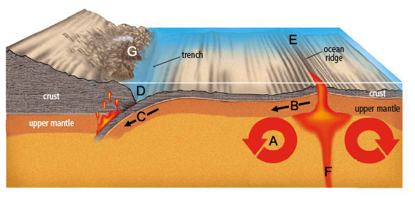

21) Complete the table.
Letter | Boundary Type | Mechanism of plate motion | Crust is created or destroyed? | Motion of plates | Magma rises or sinks? | Geographical  features
C
B
Point A represents what mechanism of plate motion?

